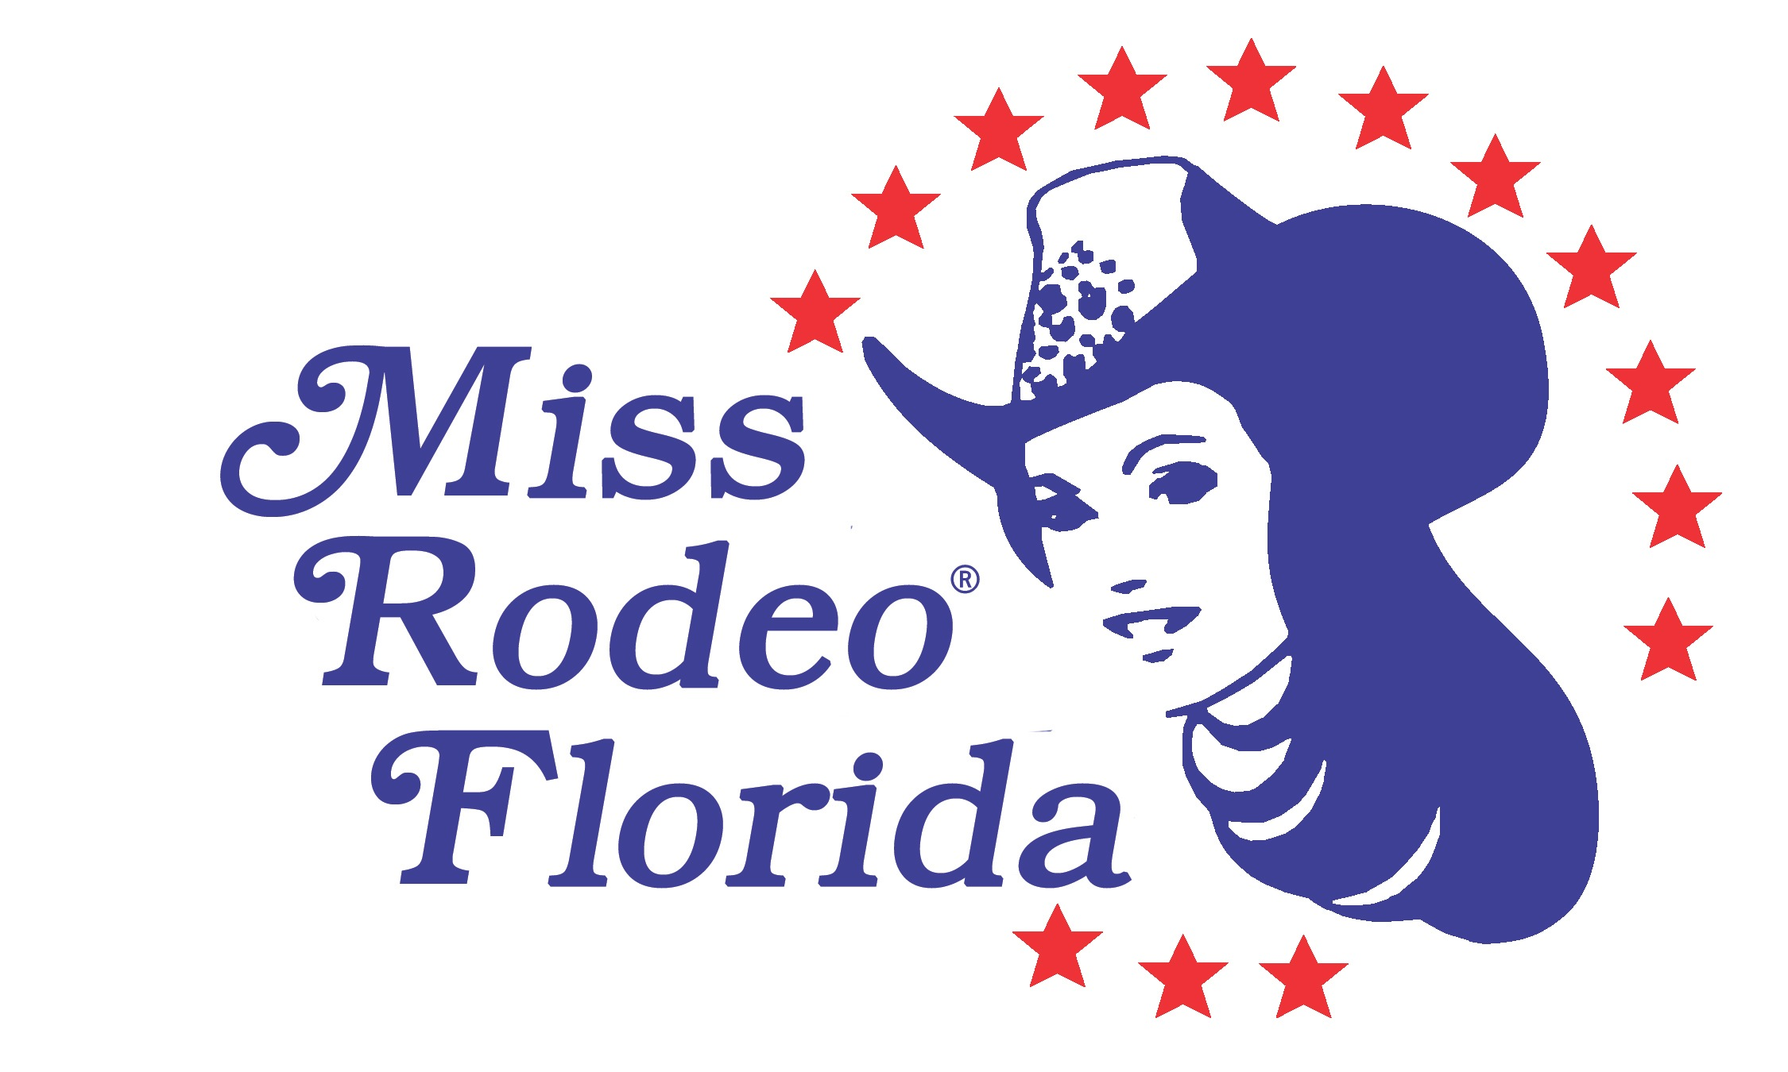

Dear Prospective MRF Member,

On behalf of the Board of Directors for the Miss Rodeo Florida Association, Inc. we would like to thank you for your interest in membership in our organization. It is the objective of this association to conduct and operate the events and activities of the annual Miss Rodeo Florida Pageant. As a member, you will be expected to give volunteer hours in the effort to support the events of the pageant and throughout the year.

The membership application process is detailed below:

*Completed application returned to MRFA,I
*Review by the nominating committee
*If recommended by the nominating committee, the application will then be voted on by the Board of Directors.

Upon approval of your application, you would then pay the annual membership dues and become a member. We would like to encourage you to take advantage of the discount we offer by joining both the MRFA and the Miss Rodeo America Association at the same time. As our state association is an extension of the national program we feel it is a great benefit to our members to be a part of both, and an excellent way for you to stay informed of our national events and to keep up with the travels, activities, sponsors and the journey of Miss Rodeo America.

Sincerely,

Nominating Committee Chairperson

Building Confidence • Achieving Dreams • Promoting Rodeo

www.MissRodeoFlorida.com

