319 Wisconsin Ave * Saint Cloud, FL 34769

Mark Kessler, National Director
(407) 957-7815 (Home) * (407) 908-4218 (Mobile)
www.missrodeoflorida.com (Website)
kesslerodeo@aol.com (Email)
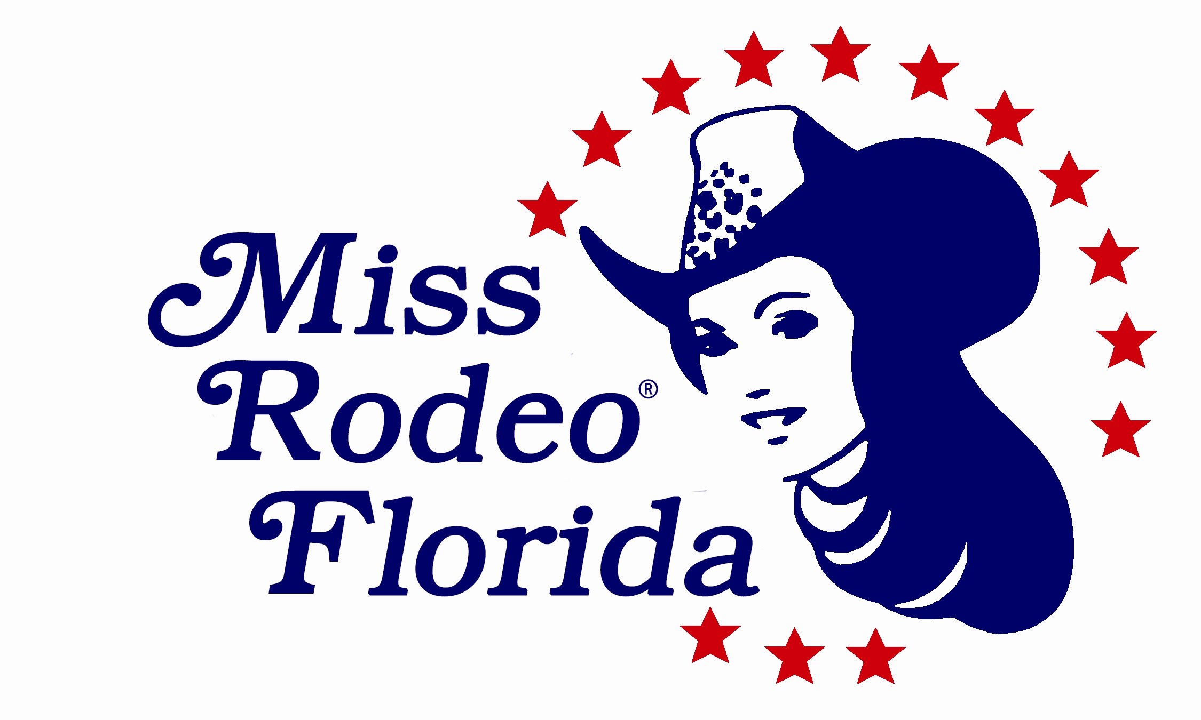

Miss Rodeo Florida Assoc., Inc.

Laura Lynn Kessler, National Director
(321) 624-9410 (Mobile)
www.missrodeoflorida.com (Website)
krazykrooner@aol.com

Dear Friends of Miss Rodeo Florida,

The Miss Rodeo Florida Association and pageant competition is a 501-c4 non-profit organization that exists for the purpose of selecting young women to serve as official spokesperson for our state, the sport of professional rodeo and providing educational opportunities for those who compete in the pageant. We are so proud and honored to support our own Keri Sheffield, 2017 Miss Rodeo Florida, as she became the first Miss Rodeo America from Florida in rodeo queen history. We could not be more proud of her as she traveled over 100,000 miles last year throughout the United States, educating and creating awareness about the sport of rodeo, its sponsors, and the many great opportunities the sport of rodeo creates.

It is this organization’s passion to help the young woman of this state to become the best they can be, not only for the sport of rodeo, but for their own future endeavors as great leaders. This year we welcome the 2019 Rodeo Queen Royalty - Miss Rodeo Florida - Cara Spirazza, Miss Teen Rodeo Florida – Kassidy Cabot, MRF Princess – Bailee Jeannin, and MRF Sweetheart – Sydnee Crawley. Our Royalty represent communities from all over the state of Florida and have taken over the proud tradition of being positive role models, rodeo ambassadors and educators about Florida’s rich cowboy history.

One of the goals of the MRFA, Inc., is to assist these young women in securing the necessary financial assistance that is required to allow them this wonderful opportunity. During their reigns, they will travel extensively throughout the State visiting as many rodeos, schools and community events as possible, spreading their love of rodeo, horsemanship, and our western culture to all they meet. Another objective is to prepare the reigning Miss Rodeo Florida for competition at the Miss Rodeo America Pageant in Las Vegas, Nevada. This endeavor requires substantial education in interview skills, modeling, horsemanship, speech and public speaking. She will need financial assistance with her wardrobe items, entry fees, photography, and out of state travel expenses.

As you can imagine, this can be quite costly, so it is our hope that you will take a moment to review all of the exciting sponsorship opportunities in the attached proposal. Please take advantage of this unique way of promoting your organization or business, while supporting these young women. We have tried to structure the various levels so that we offer a service that is of value to you. We will be happy to discuss other options and make adjustments to your benefits that may be more appealing to your business. If you care to donate another amount that is not listed, or perhaps a service item, it will be gratefully appreciated as well.

Thank you for allowing us the opportunity to tell you a little about the Miss Rodeo Florida Program. If you have any questions or are interested in becoming a member of the MRFA, Inc., please feel free to contact us at the numbers, email, or website listed above.

Sincerely,
Laura Lynn Kessler
National Director

Sponsor Packages

Diamond Sponsor ($5000 +)
* Logo and Listing in Miss Rodeo America Program Book
Logo and Listing on Miss Rodeo Florida Autograph Sheet
Logo and Listing in Miss Rodeo Florida Pageant Program
Logo and Listing on Miss Rodeo Florida Website (Link to Sponsor’s website if available)
Four Complimentary Admissions to all Miss Rodeo Florida 2019 Pageant Events
Recognition Award at Miss Rodeo Florida 2019 Pageant
Signage (Provided by Sponsor) displayed at Pageant and other MRFA Fundraising/Special Events
Four Scheduled Appearances of Miss Rodeo Florida and/or MTRF at Company Events

Platinum Buckle Sponsor ($1000 - $4999)
* Logo and Listing in Miss Rodeo America Program Book
Logo and Listing on Miss Rodeo Florida Autograph Sheet
Logo and Listing in Miss Rodeo Florida Pageant Program
Logo and Listing on Miss Rodeo Florida Website (Link to Sponsor’s website if available)
Two Complimentary Admissions to all Miss Rodeo Florida 2019 Pageant Events
Recognition Award at Miss Rodeo Florida 2019 Pageant
Signage (Provided by Sponsor) displayed at Pageant and other MRFA Fundraising/Special Events
Two Scheduled Appearances of Miss Rodeo Florida and/or MTRF at Company Events

Gold Buckle Sponsor ($750 - $999)
* Listing in Miss Rodeo America Program Book
Logo and Listing on Miss Rodeo Florida Autograph Sheet
Logo and Listing in Miss Rodeo Florida Pageant Program
Logo and Listing on Miss Rodeo Florida Website (Link to Sponsor’s website if available)
Miss Rodeo Florida and/or MTRF Scheduled Appearance at Company Event

Silver Buckle Sponsor ($500 - $749)
Listing on Miss Rodeo Florida Autograph Sheet
Listing in Miss Rodeo Florida Pageant Program
Logo and Listing on Miss Rodeo Florida Website (Link to Sponsor’s website if available)
Miss Rodeo Florida and/or MTRF Scheduled Appearance at Company Event

Bronze Buckle Sponsor ($250 - $499)
Listing in Miss Rodeo Florida Pageant Program
Logo and Listing on Miss Rodeo Florida Website (Link to Sponsor’s website if available)
Miss Rodeo Florida and/or MTRF Scheduled Appearance at Company Event

Copper Buckle Sponsor ($25 - $249)
Listing in the Miss Rodeo Florida Pageant Program

* Deadline for the Miss Rodeo America & Miss Rodeo Florida Program Book is August each year. All Sponsorship Packages are for the donation of Cash, Product, or Services. All Miss Rodeo Florida appearances are limited to availability so schedule Miss Rodeo Florida apperances early as her schedule fills up fast!
Thank you for all of your support to Miss Rodeo Florida and the sport of Professional Rodeo.

2019 SPONSOR AGREEMENT

I have read and agreed to the details outlined for the specific sponsorship I have selected:

Diamond: ____ Platinum: ____ Gold: ____ Silver: ____ Bronze: ____ Copper: ____
General Fund Specific Donation_____________________

Business Name: ________________________________
Contact: ________________________________
Mailing Address: ________________________________
City / State / Zip: ________________________________
Office Phone: ________________________________
Mobile Phone: ________________________________
Fax: ________________________________
Email: ________________________________

Signature ________________________________
Date ________________________________

Building Confidence • Achieving Dreams • Promoting Rodeo

www.MissRodeoFlorida.com
a 501-c4 organization

Accepted By: ________________________________
Miss Rodeo Florida Assoc., Inc. – National Director
Date ________________________________

