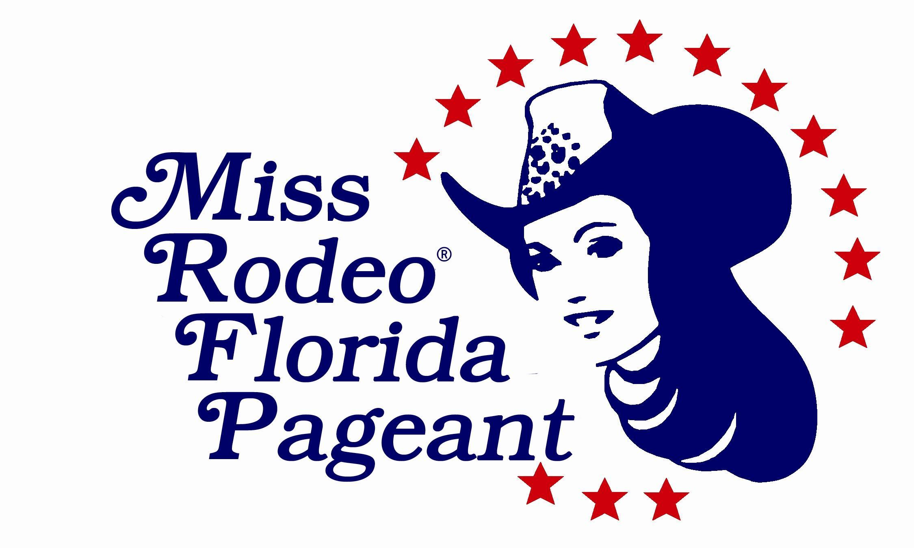
MISS RODEO FLORIDA / MISS TEEN RODEO FLORIDA
MISS RODEO FLORIDA PRINCESS/ SWEETHEART

TENTATIVE 2026 PAGEANT SCHEDULE

DATE | TIME | EVENT | LOCATION | WARDROBE
Friday  November 7, 2025 | 9:00 – 10:00AM | Judges Orientation  Meeting/Photogenic Pic | Hilton Ocala
Friday  November 7, 2025 | 9:00 - 9:30AM | All Contestants  Check-In, Money, Auction Items and Accommodation Assignments  (Contestants/Parents & MRF Committee) | Hilton Ocala | Wrangler Pant Product of your choice (any color), Western long sleeve blouse with, any color, blouse may be embellished, shirt tucked in, western boots and cowboy hat.
Friday  November 7, 2025 | 9:30 – 10:00AM | Pageant Orientation  All Contestants  (Parents, Judges, & MRF Committee) | Hilton Ocala | Same Outfit as Check In
Friday  November 7, 2025 |  | Room Move In  (Judges, Chaperones, Miss) | Hilton Ocala | Same Outfit as Check In
Friday  November 7, 2025 | 10:00 - 11:00AM | Dance Rehearsal  MTRF/Princess/ Sweetheart | Hilton Ocala | Same Outfit as Check In
Friday  November 7, 2025 | 11:00 - 12:00PM | Written Test  MRF & MTRF | Hilton Ocala | Same Outfit as Check In
Friday  November 7, 2025 | 12:00 - 12:45PM | Lunch  All Contestants  with Judges | Hilton Ocala | Same Outfit as Check In
Friday  November 7, 2025 | 12:45 - 1:00PM | Prepare for Interviews  MRF/MTRF | Hilton Ocala
Friday  November 7, 2025 | 1:00 PM - 4:00PM | Personality Impromptu Questions and Speech  (All – Speech, 2 Personality Questions) | Hilton Ocala | Western business attire: A modern, professional dress/skirt/slacks paired with a blouse and/or jacket or vest. Skirt or dress length should be no more than 2 inches above the knee. Outfit must be worn with boots, a cowboy hat, belt, and buckle, and should be appropriate for a professional speaking engagement.
Friday  November 7, 2025 | 6:00 PM -9:00PM | Personality Interviews  MRF/MTRF/Princess/Sweetheart | Hilton Ocala | Same outfit as Speech
Saturday  November 8, 2025 | 7:00 – 7:45AM | Breakfast  MRF Contestants Only  (Chaperones & Designated MRF Committee) | Hilton Ocala | Horsemanship Outfit: Wrangler Pant Product of your choice, long sleeve shirt tucked in (shirt may be embellished ), western boots and cowboy hat.
Saturday  November 8, 2025 | 7:45 - 8:15AM | Break  Prepare for Horsemanship  Travel time 30-35 min | Travel time
Saturday  November 8, 2025 | 8:15 - 8:45AM | Horsemanship  Warm Up  MRF/MTRF/MRFP | Albritton Reining Facility
Saturday  November 8, 2025 | 9:00-11:00AM | Horsemanship  Competition  MRF/MTRF/MRFP/MRFS | Albritton Reining Facility | Horsemanship Outfit: Wrangler Pant Product of your choice, long sleeve shirt tucked in (shirt may be embellished), western boots and cowboy hat.
Saturday  Sept 28, 2024 | 11:30 - 1:00PM | Lunch  All Contestants  (Judges & Designated Committee) | Albritton Reining Facility | Travel time back to hotel 30 min
Saturday  Sept 28, 2024 | 1:00 - 1:30PM | Travel time 30-35 min
Saturday  Sept 28, 2024 | 1:30 - 3:00PM | Horsemanship Interview  MRF/MTRF/MRFP  *MRFS does not have horsemanship interview* | Hilton Ocala | Same as Horsemanship Outfit: Wrangler Pant Product of your choice, long sleeve shirt tucked in (shirt may be embellished ), western boots and cowboy hat.  May add Jacket or Vest for Horsemanship Interview
Saturday  Sept 28, 2024 | 3:00 - 4:00PM | Dance & Modeling Practice | Hilton Ocala
Saturday  Sept 28, 2023 | 6:00 - 9:00PM | Fashion Show / Coronation  All Contestants  (Dance, Modeling, 2 Rodeo Questions, Live & Silent Auction) | Hilton Ocala | Wear Wrangler Jeans and Dance Shirt for Arrival  Western Elegance dress/skirt with blouse and/or jacket/vest, boots,  cowboy hat, belt & buckle.
Saturday  Sept 28, 2023 | Following Fashion Show | Coronation  Crowning of the 2026 MRF/MTRF/MRFP/MRFS | Hilton Ocala | Same outfit as Fashion Show

Pageant Schedule is Subject to Change.

Please note that MRF Contestants are required to stay together Friday night and will share a room with another contestant. All food and rooms are covered with your entry fee. MRF Contestants will be under the supervision of designated chaperones during the entire pageant.

MTRF are under the supervision of their parents, except at pageant events and
rehearsals where the pageant chaperones will be in charge.

Princess and Sweetheart Contestants are under the supervision of their parents, except at pageant events and rehearsals where the pageant chaperones will be in charge.

