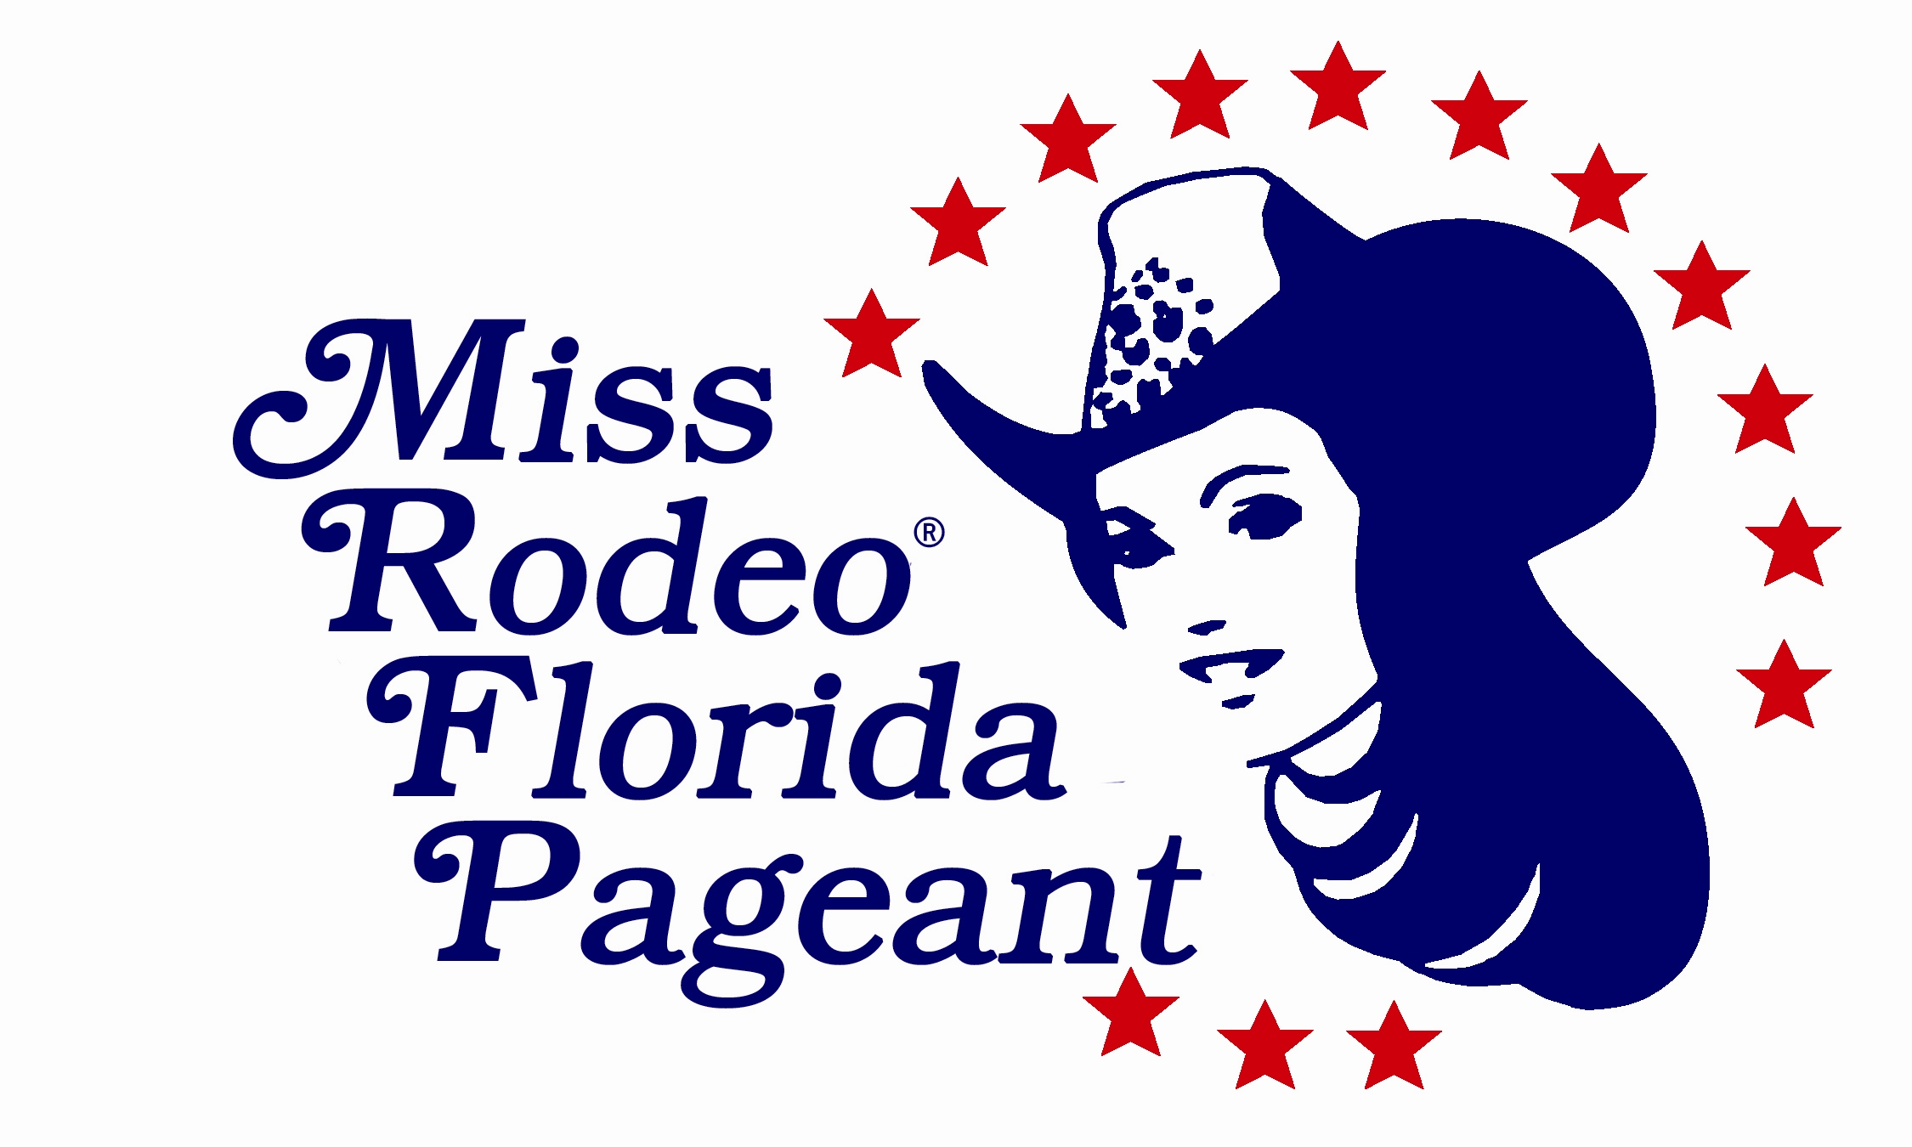
MISS RODEO FLORIDA / MISS TEEN RODEO FLORIDA
MISS RODEO FLORIDA PRINCESS/ SWEETHEART

2024 TENTATIVE PAGEANT SCHEDULE

DATE | TIME | EVENT | LOCATIoN | WARDROBE
Friday  Sept 9, 2022 | 9:00 – 10:00  A.M. | *Judges Orientation  Meeting/Photogenic Pic | The Magnolia Rom | Assigned MRF Committee
Friday  Sept 9, 2022 | 9:00-10:00 A.M. | ***All Contestants  Check-In, Money, Auction Items and Accommodation Assignments  (Contestants/Parents & MRF Committee) | The Magnolia Room | MRF/MTRF  (Horsemanship Outfit)  Wr Wrangler® Pant Product of your choice (any color). Solid colored long sleeved shirt tucked in  ( (any color-unembellished),  W western boots & cowboy hat.  May add vest or jacket for Interview  Princess/Sweetheart  (Check In Outfit)  Wrangler® Pant Product of Your Choice, Western shirt with long sleeves (May be embellished), any color, shirt tucked in, western boots and cowboy hat.
Friday  Sept 9, 2022 | 10:00-10:20 P.M. | ***Pageant Orientation  All Contestants  (Parents, Judges, & MRF Committee) | The Magnolia Room | (Same Outfit as Check-In)  Parents Released until pick up at 12:45 pm
Friday  Sept 9, 2022 | 10:30-12:00  P.M. | *Dance Rehearsal  Princess/ Sweetheart  MRF/MTF if not in interview will be practicing dance | The Magnolia Room | (Same Outfit as Check-In)
Friday  Sept 9, 2022 | 10:30-12:00  P.M. | *Horsemanship Interviews  MRF & MTRF | The Magnolia Room | (Same Outfit as Check-In)
Friday  Sept 9, 2022 | 12:30-1:00  P.M. | *Lunch  All Contestants  with Judges | The Magnolia Room | (Same Outfit as Check-In)  Publix Subs
Friday  Sept 9, 2022 | 1:00-1:15  P.M. | *Break  MRF/MTRF  Prepare for Horsemanship  PRINCESS/SWEETHEART  Parent Pick up | The Magnolia Room | (Same Outfit as Check-In)
Friday  Sept 9, 2022 | 1:15-1:30  P.M. | Leave to head to McCormick Research Institute  Princess/Sweetheart  Parents pick up | The Magnolia Room | (Same Outfit as Check-In)  A committee member will drive MRF/MTRF contestants to horsemanship
Friday  Sept 9, 2022 | 1:30–2:00  P.M. | ***Horsemanship  Warm Up  MRF/MTRF | McCormick Research  Institute | Please assign a parent or representative to be on site and have your horse saddled and ready before you arrive
Friday  Sept 9, 2022 | 2:00-4:00  P.M. | ***Horsemanship  Competition  MRF/MTRF  Welcome but  Not Mandatory  Princess/Sweetheart | McCormick Research  Institute | (Same Outfit as Check-In)
Friday  Sept 9, 2022 | 4:00-4:20  P.M. | Drive back to The Ranch | McCormick Research  Institute | (Same Outfit as Check-In)  MRF Committee member will drive MRF/MTRF  Parents drive Princess/Sweetheart
Friday  Sept 9, 2022 | 4:20-6:00  P.M. | *Dance and Modeling Practice  All Contestants | The Magnolia Room | Princess/Sweetheart arrive at The Ranch at 4:20 P.M
Friday  Sept 9, 2022 | 6:00-6:30  P.M. | *Dinner  All Contestants  (Designated MRF Committee) | The Magnolia Room | Pizza Party Dinner
Friday  Sept 9, 2022 | 6:30 P.M. | ***Parent Pick Up  MTRF/Princess/  Sweetheart | The Magnolia Room | MTRF/Princess/Sweetheart Parent pick up at 6:30 P.M
Friday  Sept 9, 2022 | 5:00-8:00 P.M. | *Judges Dinner Out | TBA | (Designated MRF Committee)
Saturday  Sept 10, 2022 | 7:00–7:20  A.M. | *Breakfast  MRF Contestants Only  (Chaperones & Designated MRF Committee) | Holiday Inn | MRF  Wrangler Pant Product of your choice, Western Shirt with Long Sleeves (May be Embellished), any color, shirt tucked in, Western Boots and Cowboy Hat.  Vests or Jackets may be added
Saturday  Sept 10, 2022 | 8:00 A.M. | *Arrive for Personal Interviews  All Contestants | The Magnolia Room | All Contestants  Wrangler Pant Product of your choice, Western Shirt with Long Sleeves (May be Embellished), any color, shirt tucked in, Western Boots and Cowboy Hat.  Vests or Jackets may be added
Saturday  Sept 10, 2022 | 8:15-12:15  A.M. | *Personal Interviews  2 Current Event Questions  All Contestants  Starting with Sweetheart/Princess | The Magnolia Room | (Same Outfit)
Saturday  Sept 10, 2022 | 8:15-9:15  A.M. | *Written Test  MRF/MTRF | The Magnolia Room | (Same Outfit)
Saturday  Sept 10, 2022 | 12:15-12:45  P.M. | *Lunch  All Contestants  (Judges & Designated Committee) | The Magnolia Room | (Same Outfit)
Saturday  Sept 10, 2022 | 12:45-2:00  P.M. | *Dance Practice and Modeling  All Contestants | The Magnolia Room | (Same Outfit)
Saturday  Sept 10, 2022 | 2:00 P.M. | Parent Pick Up  Sweetheart/Princess/  MTRF |  | Committee will Drive MRF
Saturday  Sept 10, 2022 | 2:00-5:00  P.M. | Get Ready for Fashion Show  All Contestants | Hilton Inn | All Contestants  Fashion Forward Western Outfit. May be Knee/Tea/Floor length Skirt/Dress, Western Boots and Cowboy Hat
Saturday  Sept 10, 2022 | 5:00-5:30  P.M. | Coastal Cowgirls  Fashion Show  *Final Dance Rehearsal  All Contestants  (Chaperones & Designated MRF Committee) | The Magnolia Room | Arrive in dance Shirt (provided at Orientation),Dark Wrangler Blue Jeans, Western Boots and Cowboy Hat.  Bring your Fashion Forward outfit to change into after Dance
Saturday  Sept 10, 2022 | 5:30 P.M. | Doors Open to Public | The Magnolia Room | Dolly’s Dazzling Fashion  Show  (Dance Outfit)
Saturday  Sept 10, 2022 | 6:00-9:00 P.M. | **Coastal Cowgirls Fashion Show  All Contestants  (Dance, Modeling, All - 2 Rodeo Questions, Live & Silent Auction) | The Magnolia Room | (Dance Outfit)  Change into Fashion Forward Outfit after Dance  All Contestants  Western Fashion Forward Outfit. May be Knee/Tea/Floor length Skirt/Dress or Long Pants/ Long pant Jumpsuit, Western boots and Cowboy Hat
Saturday  Sept 10, 2022 | 9:00 P.M. | End of Dinner | The Magnolia Room | Committee members will release Contestants to Parents  MTRF/Princess/  Sweetheart Contestants
Sunday  Sept 11, 2022 | 8:30 A.M. | *Arrive for Coronation  All Contestants | The Magnolia Room | All Contestants  Blingy Arena / Western Long Sleeve Shirt, Vest and/or Jacket Combo. Cowboy Hat and Western Boots.  (Bring your Fashion Dress Outfit to change into for Award Ceremony)
Sunday  Sept 11, 2022 | 9:00 A.M. | ** Coronation  ALL CONTESTANTS  (All - 2 Personality Questions, Speeches, Raffle Draw) | The Magnolia Room | All Contestants  Blingy Arena / Western Long Sleeve Shirt, Vest and/or Jacket Combo. Cowboy Hat and Western Boots.  (Bring your Fashion Dress Outfit to change into for Award Ceremony)
Sunday  Sept 11, 2022 | 12:00 P.M.  Following Awards Presentation | ***Awards Ceremony  ALL CONTESTANTS  2022 All Queens and  1st Runner-Ups  to have a short meeting | The Magnolia Room | All Contestants  (Same Dress Outfit as  Fashion Show)  All Prize Pkgs will be given at time of contract signing. Date and time TBA

Pageant Schedule is Subject to Change.

*Closed to Public
**Open to Public with Purchase of Ticket
***No Charge

(Long Sleeves, Western Hats, Belts and Boots are mandatory for all contestants at each
event unless otherwise noted).

MRF denotes Miss Rodeo Florida Contestants
MTRF denotes Miss Teen Rodeo Florida Contestants

Please note that MRF Contestants are required to stay together Friday and Saturday and will share a room with another contestant. All food and rooms are covered with your entry fee. MRF Contestants will be under the supervision of designated chaperones during the entire pageant.

MTRF are under the supervision of their parents, except at pageant events and
rehearsals where the pageant chaperones will be in charge.

Princess and Sweetheart Contestants are under the supervision of their parents,
except at pageant events and rehearsals where the pageant chaperones will be in
charge.

