- 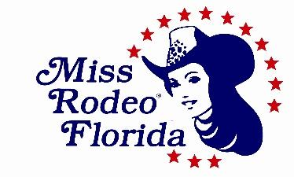
Parents and Guests Ticket Reservation Form
(All contestants’ meals as listed below are included with entry fee)

- Name:_________________________________________________________________________________
- Last First
- Address:_______________________________________________________________________________
Street, City, State, Zip
- Telephone:____________________________________Email: ___________________________________

Date | Event | Number Attending | Price | Total Price
Saturday  09/11/21  @ 6:00pm | “Seas the Day” Dinner  (Hastings Ranch) |  | @$25.00 | $
 | Child’s Dinner  (10 and under) |  | @$8.00 | $
Sunday  09/12/21  @ 10:00am | Fashion Show Brunch  (Hastings Ranch) |  | @$20.00 | $
 | Child’s Dinner  (10 and under) |  | @$8.00 | $
 |  |  | Total amount due | $

Please make checks payable to MRFA, Inc. All reservations for the above events must be postmarked
and mailed by July 31, 2021 or included with contest’s application.

Please mail them to the following address: Miss Rodeo Florida Association, Inc.
Jessica Kelly– Pageant Director
4876 Oriole Drive Saint Cloud, Fl. 34772
E-mail: missrodeoflpageant@gmail.com
Cell/ 321-624-9341

Prepaid Tickets for the events may be picked up during registration or at the door of the event under your last name. Please note that any tickets purchased at the door are on a first come basis and will incur a $5.00 additional fee per ticket.

