2022
Miss Rodeo Florida
Miss Teen Rodeo Florida
Miss Rodeo Florida
Princess/Sweetheart Pageant

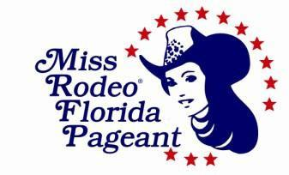

OFFICIAL PAGEANT RULEBOOK
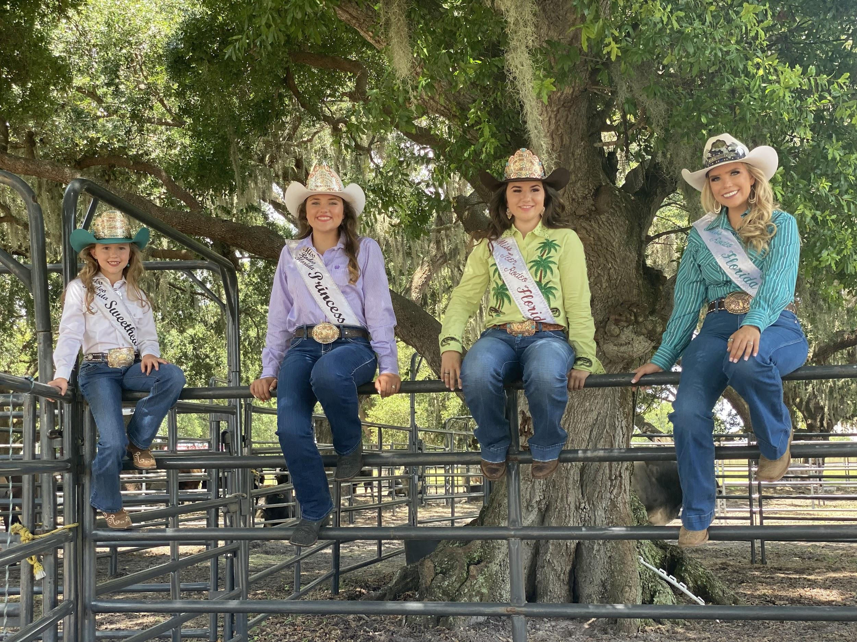
Pageant Rules and Regulations, revised May 2021

For further information or assistance, please contact:
Miss Rodeo Florida Association, Inc.

Jessica Kelly missrodeoflpageant@gmail.com
Check the website for updates and information.
www.missrodeoflorida.com
ALL RIGHTS RESERVED
Copyright © 2021 by Miss Rodeo Florida Assoc., Inc.

Who is Miss Rodeo Florida/Miss Teen Rodeo Florida?
Miss Rodeo Florida/Miss Teen Rodeo Florida symbolizes the youth of our State who wish to further promote the sport of professional rodeo and western way of life. She is the ideal, western type American girl, and is the person who will represent professional rodeo as she travels our state and country.

What does it mean to be Miss Rodeo Florida/Miss Teen Rodeo Florida?
While spreading good will for her community, her state, and her country, Miss Rodeo Florida/Miss Teen Rodeo Florida is garnering the richest experience of her life and laying a solid foundation for her future. She may receive a scholarship to help further her education along with gifts, donations, and accessories.

The value of Miss Rodeo Florida/Miss Teen Rodeo Florida to her home state is limitless.
During her reign, she is the state’s Official Representative of the Professional Rodeo Cowboys Association, and should constantly be aware of those values of public relations between the general public and those actively involved in pro rodeo. It is her responsibility to improve the image of rodeo to all with whom she comes in contact. The experience gained as she travels across her state, and perhaps other parts of the country, can be one, which will enrich her life in countless ways.

About Miss Rodeo Florida Princess/Miss Rodeo Florida Sweetheart?
The Miss Rodeo Florida Princess/Sweetheart titles are designed as a stepping stone in a young lady’s life to prepare her for future rodeo queen titles and responsibilities. The best way to learn is by hands-on experience shadowing the senior Miss and Teen and will follow the same guidelines and rules as the Miss Rodeo Florida/Miss Teen Rodeo Florida Contestants.

What type of young lady does the Miss Rodeo Florida/Miss Teen Rodeo Florida Pageant attract?
- The young lady who wishes to be a leader in her community, and further promote the western way of life on a local, state, and national basis.

- The young lady who loves horses and everything they represent, and who wants to show the rest of the world what can be accomplished while surrounded by this environment.

- The young lady who wants to act as an official representative of professional rodeo, portraying good sportsmanship and high moral and ethical character, and reflecting careful and humane treatment of animals. She should understand the sport of rodeo in its entirety, enough to be able to explain and “sell” rodeo to anyone with whom she may come in contact, and be able to speak intelligently, with dignity and sincere interest in rodeo. She should realize that the Miss Rodeo Florida/Miss Teen Rodeo Florida Pageant is not a beauty pageant. However, she should act, speak, and dress according to the prestige the title deserves.

- The ambitious young lady who is interested in furthering her chosen career.

How can a young woman become royalty for the Miss Rodeo Florida Pageant?
To compete in the Miss Rodeo Florida Pageant, one must meet all requirements set forth in the official pageant rule book for the Miss Rodeo Florida Pageant and the Miss Rodeo America Pageant.

CONTESTANT ELIGIBILITY: Each contestant in the Miss Rodeo Florida Pageant shall on the date of competition:

- NEW - MRF contestant (19-26) is to be a natural born female that has obtained the age of 19 years and shall not have obtained the age of 27 years by December 31st of the pageant year, the same to be evidenced by her birth certificate presented before competition.
- MTRF contestant (15-18) is to be a natural born female that has obtained the age of 15 years and shall not have obtained the age of 19 years by December 31st of the pageant year, the same to be evidenced by her birth certificate presented before competition.
- MRF Princess contestant (11-14) is to be a natural born female that has obtained the age of 11 years and shall not have obtained the age of 15 years by December 31st of the pageant year, the same to be evidenced by her birth certificate presented before competition.
- MRF Sweetheart contestant (7-10) is to be a natural born female that has obtained the age of 7 years and shall not have obtained the age of 11 years by December 31st of the pageant year, the same to be evidenced by her birth certificate presented before competition.
- If the contestant is not presently enrolled in school, she must be a high school graduate or hold a GED.
- Must not have previously been, or presently been married and/or pregnant.
- Be a resident of the state of Florida for six months, and shall reside within the State of Florida during the entire year of
her reign.
- Must never have been a prior contestant in the Miss Rodeo America Pageant.
- Must not be a state or national titleholder of any other pageant in the year of competition.
- Have executed all consents and/or waivers of liability presented as condition precedents to the competition.
- Have never been disqualified and/or title forfeited in the Miss Rodeo Florida/Miss Teen Rodeo Florida Pageant or any other state pageant/contest.
- There is no limit to the number of times an individual can compete in the Miss Rodeo Florida/Miss Teen Rodeo Florida Pageant as long as the contestant meets eligibility requirements.
- Must abide by all rules and regulations of the Miss Rodeo Florida/Miss Teen Rodeo Florida Pageant.
- Must never have been convicted or pled no contest to a felony charge.

Any contestant not meeting the qualifications set forth above shall be denied the right to compete in the Miss Rodeo Florida/Miss Teen Rodeo Florida Pageant.

RULES OF CONDUCT:
- Contestants must conduct themselves in a proper lady-like manner and portray high moral standards at all times.
- Contestants will not be permitted to drink alcoholic beverages, use illegal narcotics, paraphernalia, tobacco products,
or use foul language at any time during the pageant.
- Contestants, or any individual related to a contestant, must not approach Judges with the intent to influence or harass.
- Contestants will not be allowed to carry or use cell phones until the completion of the pageant.
- Upon commencement of the pageant, contestants will be under the jurisdiction of the MRFA, Inc. Parents and
Friends are encouraged to attend pageant activities, but will not be allowed to visit with contestants in their rooms. Any items to be given to the contestants should go through the front desk or chaperones.
- Contestant and her family and friends are expected to display the highest degree of sportsmanship during the
pageant and particularly following the Coronation Ceremony.
- Contestants will be well prepared, groomed, dressed appropriately and on time for all activities.
- Contestants will not accept coaching, prompting or assistance of any kind from family or friends during competition.
- Contestants will not leave pageant facility/property at any time during the pageant, unless being escorted by a
chaperone or MRFA, Inc. official.

Failure to abide by these Rules of Conduct may result in disqualification from the competition. Any and all illegal activity will be reported immediately to authorities.

LOSS OF TITLE AND BENEFITS:
- Subsequent to the Miss Rodeo Florida Pageant, any person being awarded the title of Miss Rodeo Florida/Miss Teen Rodeo Florida and/or otherwise becoming the successor thereto, shall not;
- Become publicly engaged, married and/or pregnant at any time prior to or during her reign.
- Be charged with and/or determined to have committed any crime of moral turpitude.
- Compete in and/or otherwise participate in any other beauty and/or talent contest, pageant and/or activity.
- Solicit, negotiate, or contract with any third person for appearances, photographs, interview, sponsorship, and/or endorsement, during the year of her reign without the express permission of the MRFA, Inc. and it’s Board.

Upon the occurrence of any of the above events, the title of Miss Rodeo Florida/Miss Teen Rodeo Florida together with any and all benefits derived by such person, shall be forfeited, and awarded to the next qualified runner-up. If such is discovered after her reign, the winner may be liable for repayment of any cash or awards she may have received during her reign.

JUDGES;
1. There should be three to five judges depending on the number of contestants and is at the discretion of the MRFA,
Inc.
2. Judges will score all categories of the Pageant. All scores will be totaled for each contestant each time they are
judged.
3. Should a judge become incapacitated during the pageant, judging will continue with remaining judges, for the
remainder of the pageant or until the incapacitated judge can resume.
4. Judges are selected for their expertise in all fields of the competition. They should all have an awareness of correct
western dress, they should be knowledgeable about the sport of professional rodeo, and they should be experienced
western-type horsemen and horsewomen who are accustomed to judging horse events.

JUDGING GUIDELINES:
All Contestants will be judged in the following categories: Personality, Appearance, Personal Interviews, Modeling, Impromptu Questions (Rodeo/Personality/Current Events), Most Photogenic and a Speech. Miss/Teen have further judged categories: Written Test, Horsemanship Interview, Horsemanship Riding Competition and the salesmanship of their live auction item. Most Photogenic is chosen, not scored, and does not count toward contestants overall score.

JUDGED EVENTS:
- Most Photogenic: All Contestants: The judges will score the required color 8 x 10 vertical, head and shoulder photograph submitted by each contestant, to determine the winner of this category. Contestant must submit 1 8x10 and 4 5x7’s (No hard or stiff backing on photographs and all photographs become the property of the MRF/MTRF Pageant AND WILL NOT BE RETURNED TO CONTESTANT). This honor award score is not added into the contestants’ final score.
- Personal Interviews: All Contestants will be interviewed privately. Judges choose topics which may include: pageant information, past queen alumni, rodeo knowledge, and information on application, local/state knowledge and current events. There will be an Impromptu Question asked during this event that scores will be added into the final score.
- Modeling: All Contestants will participate in at least one fashion show and may create their own modeling “T” pattern.
- Impromptu Questions: All Contestants will be asked questions during pageant functions which may relate to the sport of professional rodeo, equine science, personality types and/or current events.
- Written Test: MRF/MTRF: A written test will be given to MRF/MTRF contestants. The test may include but is not limited to aspects of your State, Rodeo, Horsemanship, Equine Science, Current Events, Etc., Miss Rodeo America, etc. This test is worth 100 points. The results of the test will be added into the contestants’ final score.
- Live Auction Item: (MRF/MTRF only) contestant is required to bring a live auction item and will be judged on how they present and sell their item at the live auction during Saturday evenings BBQ Event. Princess/Sweetheart: Contestant is required to bring a silent auction item that will help the Scholarship Program.
- State Speech: Each MRF/MTRF contestants are required to give a (2) two-minute speech on ―The state of Florida or any aspect of Florida. The contestant with the highest total score in the speech competition will be recognized with a special award and points given on the final score. Princess/Sweetheart: Contestants are required to give a no more than (1) minute speech on: “Why they would like to be Miss Rodeo Florida Princess/Sweetheart”.
- Horsemanship: MRF/MTRF: There will be two go-rounds of the horsemanship competition. Please see below, page 5, description of the event. All horses entering the Equestrian Facility grounds are required to have a current health inspection and Coggins test.
- Horsemanship Interview: MRF/MTRF: Judges choose topics which may include: professional rodeo, horsemanship, knowledge of tack, horse care, feeding, diseases, anatomy, etc.; knowledge of professional rodeo, its history, organization, rodeo terminology or vernacularly, explanation of standard events, awareness of PRCA and the WPRA/PWRA championship standings, and goings-on in the pro rodeo world. (Excellent sources of information are available from: PRCA, 101 Pro Rodeo Drive, Colorado Springs, CO 80919; WPRA, 1235 Lake Plaza Drive Suite 134, Colorado Springs, CO 80906).

SCORING:
- The contestant receiving the highest grand total score, IN EACH OF THEIR TITLE GROUPS, for the competition shall be crowned Miss Rodeo Florida/Miss Teen Rodeo Florida. The contestant receiving the second highest grand total shall be first runner-up. There shall be no other runner-up categories announced for the MRF/MTRF division. The contestant scoring the highest grand total score for the Miss Rodeo Florida Princess and Miss Rodeo Florida Sweetheart competition shall be crowned Miss Rodeo Florida Princess and Miss Rodeo Florida Sweetheart respectively.
- Judge #1s score will break the tie for category winners, Appearance, Personality, Speech and Horsemanship. If a tie still remains, Judge #2s score will be used . . . and so on until the tie is broken. A tie for Miss Congeniality will be broken by the second balloting by contestants. A tie for Miss Rodeo Florida/Miss Teen Rodeo Florida and runners-up will be broken by the horsemanship scores; the contestant with the highest score in horsemanship will receive the higher ranking.

Judge’s Score Sheets:
Each judge will place his/her score sheets in a manila envelope, seal the envelope, and sign his/her name across the flap. The judge’s chaperone will collect the score sheets after each scored section and keep them safe until such time as the accountants can retrieve them and tabulate them in private.

PAGEANT DIVISIONS:

A. APPEARANCE: The purpose of this judged division is to select the young lady who rates highest in:

1. Attractiveness
2. Grooming: to include neatness and cleanliness in every detail, such as complexion, hands, fingernails, hair, hat,
boots, and other apparel. Meticulous care in general grooming is essential for a young lady to be considered as Miss
Rodeo Florida royalty.
3. Photogenic Quality: Judges will have (1-8x10) (4-5x7’s) a head and shoulder picture to study of each contestant. A young lady’s strength of character and personality are reflected strongly in a wholesome appearance.
4. Poise and Posture: Lady-like behavior in every situation.
5. Knowledge of Proper Western Attire: Contestants should be aware of what is fashionable western dress, with
particular attention given to color coordination (contestants should know how the use of various color combinations
can enhance appearance and eye appeal). Judges will be observing how a contestant’s clothes fit and suit her form
and personality.
6. Contestants are expected to appear in: Full western attire, at all times, unless otherwise specified. All outfits
should include western hat, boots, and belt. Hat shapes are looked at so go to someone knowledgeable to fit your
face.
7. It is mandatory that contestants wear WRANGLER® pant products whenever they are in pants.
8. Dresses, skirts, and blouses should reflect a western image. Dresses must be Knee/Tea or Floor Length.
Garments and accessories must exhibit a western image.
9. It is not necessary to invest in an excessive amount of expensive clothing. Judges will be looking for versatility and
imagination displayed by the contestants.
10. Contestants should be knowledgeable on current trends in western wear manufacturing.

B. HORSEMANSHIP: the purpose of this division is to select the young lady who rates highest in:

1. Horsemanship: Control of the horse and the way the contestant handles each situation that may occur.
2. Balance: Ability to sit steady in a saddle.
3. Positions: of hands, feet, and seat.
4. Mounting and dismounting.
5. Understanding and skill of the contestant will be judged and not the horse.
6. MRF/MTRF: There will be two go-rounds of the horsemanship competition. MRF contestants will draw from provided stock horses for both rounds. MTRF will provide their own mount and tack and will not switch during competition. Teens horses may not be brought onto the McCormick property until 9:00am on September 11th and may not have the use of their stalls during the competition so be prepared to tie up to your rigs. Round One will be rail work, with a flag run presented at the end of this judging event. Round Two will use one of the three patterns as included in this book, will include a dismount and mount, and will end with a queens run. The Judges will draw the pattern used and you will be advised at Orientation. At the discretion of the Judges, patterns may be altered. Any changes and/or alterations to the horsemanship patterns will be announced to the contestants before the horsemanship competition begins. The patterns will be demonstrated by the reigning Miss Rodeo Florida/Miss Teen Rodeo Florida. All horses entering the Equestrian Facility grounds are required to have a current health inspection and Coggins test.
7. Horse and tack:. MRF contestants will draw from provided stock horses for both rounds. Those horses will have tack already on them and staff will help you fit your stirrups. MTRF will provide their own mount and will provide their own tack. As in rodeo, contestants will draw for the order in which she competes.
8. No Stalls for horses: McCormick Research Institute’s barns are full with Business Horses and horses Boarded for training. They will not have stalls available for your horses at this event. We are working on locating a local place to help.
9. Injury or illness: which will not allow a horse to work, will require veterinarian certification and will then be reported to the horsemanship director who will determine whether the horse can be taken from the grounds and another horse approved for the contestant. For safety reasons, studs will not be allowed.
10. Restrictions: MRF/MTRF - There will NOT be any parents, relatives, friends, boyfriends, trainers, and etc. allowed in the horsemanship area during the competition. Also, there will be No One on and/or warming up the contestants’ horses. If so, contestant will be disqualified. (Lunging the horse is allowed)
11. Dress for horsemanship, MRF/MTRF only - Wrangler® pant product of your choice, solid colored long sleeved western shirt, any color /unembellished. Shirt must be tucked in. Western boots and cowboy hat. No vests or jackets. All riding attire should be neat and fit properly. Minimum jewelry should be worn. Showmanship should be considered, since a contestant’s personality does project from horseback to the audience and judges. No Chaps.
12. Spurs: Teen Contestants will be allowed the use of spurs during horsemanship on their own horse. Spurs will not be allowed on draw horses. (FYI, Spurs are not allowed in the MRA Pageant.)

C. PERSONALITY: the purpose of this division is to select the young lady who rates highest in:

1. Intelligence: Good common sense.
2. Education; Ability to speak about rodeo and other areas, with special emphasis on grammar and enunciation.
3. Attractiveness: not necessarily to mean beauty in this sense, but rather should note whether the contestant radiates
self-confidence without making an issue out of it. To include the contestants’ style of attire, overall appearance,
magnetism and eye appeal.
4. Personality Reflections: Conversational ability. She should show maturity, high moral standards, sincerity, and
integrity.
5. Genuine interest in other people: in the pageant and in rodeo, and a noticeable consideration for others.
6. Self-projection: Ability to project one’s personality, whether it is from horseback in an arena, on television, or before
an audience. Also, to be considered are sense of humor, showmanship, ambition, desire and enthusiasm.
7. Happy outlook on life in general.
8. Promptness in keeping pageant schedule.
9. Public Appearances- includes public appearances of contestants; giving them an opportunity to speak to an
audience with facts and interesting information about their hometown, and/or their state. These appearances may be
made at western fashion shows, civic group luncheon programs, evening meetings, banquets, etc. Contestants will be
expected to answer questions in at least one of their public appearances, with these questions prepared in advance
and drawn by the contestant or a MRF/MTRF pageant official. Some possible subjects include; rodeo terms to define,
rodeo events to explain, extemporaneous questions, all of which require the contestant to think on her feet, and
show maturity, intelligence, wisdom and imagination.
10. Judges will be provided a copy of the pageant application and photo in advance of the pageant.

Miss Rodeo Florida Pageant Requirements

1. Entry Fees: Miss Rodeo Florida - are $250, Miss Teen Rodeo Florida- are $200, MRF Princess – are $150 and MRF Sweetheart- are $150. Entry fee includes the hotel accommodations for MRF contestants. For valid entry, each application must be accompanied by proof of birth (birth certificate or baptismal certificate) signed back page of the Hold Harmless Agreement and photographs. Checks must be made out to the MRFA, Inc. All documentation, photographs and FEES must be included in the application and must be postmarked by July 31, 2021 or not valid.
2. Chaperones: The MRF contestants will be under the supervision of the MRF Assoc., Inc., and Pageant Chaperone(s) from the time they arrive until they are signed out by Pageant Officials. The chaperones will escort the MRF contestants from the hotel and the other contestants while on pageant property to and from all functions during the pageant. Chaperones duties of which will consist of making certain the contestant’s schedules and other responsibilities are met. The number of chaperones will depend on the number of contestants – a suggested guideline is one chaperone to every five contestants, with one head chaperone having full responsibility. The Teen, Princess and Sweetheart contestants will follow the same schedule as the participants in the older divisions. They will check-in and depart just as the Miss contestants but they will be under the supervision of their parents when not competing or on pageant property. Parents are responsible for transporting their daughters to functions and for getting them there on time. While competing, ALL contestants will be seated together and supervised by the Chaperones and some of the pageant committee. However, parents are asked not to approach their daughters until authorized by pageant personnel. We want to be as organized as possible. All contact and delivery of needed items, or messages with the MRF contestants will be done through the chaperones. Cell phone numbers will be given out during orientation.
3. Parents/Relatives: Parents and relatives of MRF contestants are welcome to attend certain events at which the contestants will be present. However, after pageant begins, contestants cannot communicate with family, friends, or boyfriends unless authorized by the chaperones.
4. Transportation: All transportation needs for MRF contestants to functions shall be provided. Transport of Teen/Princess/Sweethearts will be the responsibility of the parents.
5. Horsemanship: MRF/MTRF contestants - There will NOT be any parents, relatives, friends, boyfriends, trainers, etc. allowed in the horsemanship area or arena during the competition. Also there will be NO one on and/or warming up the contestants’ horses. If so, the contestant will be disqualified.
6. Video recording and photography equipment are allowed at the Pageant functions, unless directed otherwise by pageant officials.
7. Judging will take precedence over all pageant activities, beginning at the Orientation meeting for the contestants and continuing throughout the pageant.
8. All Contestants will be required to stay together for the duration of the pageant unless there is cause for emergency release. Contestant must receive approval from MRFA, Inc. officials before departure.

Dress Code for Pageant Events:
Photogenic: Outfit of your choice, 8x10 color head-and-shoulders photo. Picture must include western hat, western styled outfit, belt and boots (NO tiara or banner).
Friday - Check In/Orientation/Personal Interview: MRF/MTRF/ Princess/Sweetheart: Wrangler pant product of your choice, western shirt with long sleeves, any color/can be embellished, Western Hat/Belt/Boots. Vests or jackets are optional

Saturday Breakfast / Rehearsal / Lunch: MRF/MTRF –Horsemanship Interview outfit. Wrangler® pant product of your choice, solid, any color, long sleeve western shirt, unembellished, must be tucked in. Cowboy hat, belt, cowboy boots. Vests or jackets are optional. Princess/Sweetheart Wrangler pant product, long sleeved western shirt, tucked in. Western Hat/Belt/Boots. Even though you are not being judged, judges will still see you at lunch.

Horsemanship Interview: MRF/MTRF –Wrangler® pant product of your choice, solid, any color, long sleeve western shirt, unembellished, must be tucked in. Cowboy hat, belt, cowboy boots. Vests or jackets are optional and may be embellished.

Horsemanship: Wrangler® pant product of your choice, solid, any color, long sleeve western shirt, unembellished, must be tucked in. Western boots and cowboy hat. No vests or jackets. Same outfit as interview minus vest or jacket. All riding attire should be neat and fit properly. Minimum jewelry should be worn. Showmanship should be considered, since a contestant’s personality does project from horseback to the audience and judges. No Chaps.

Saturday Dinner: MRF/MTRF/ Princess/Sweetheart: Wrangler pant product of your choice, long sleeved western or arena sparkly type shirt, Cowboy Hat/Belt/Boots. Vests or jackets are optional and all may be embellished.

Sunday Brunch Fashion Show: MRF/MTRF/ Princess/Sweetheart: Western long dress/skirt/blouse/vest and/or jacket combo. Dresses must be Knee/Tea or Floor Length. Hat, belt, boots. All may be embellished.

AWARDS PRESENTATION:
1. MRF/MTRF/ Princess/Sweetheart: will wear the same dress outfit as the Sunday Brunch.

2. All contestants MUST attend the Awards Presentation. Should a contestant not attend, she will automatically forfeit her award and/or scholarship.

- Wrangler pant product means any fabric or style of pant that is manufactured by Wrangler®.
- Out of respect for the current Miss Rodeo Florida royalty, no crowns are to be worn.
- Consult the MRF Pageant Director or National Director for any questions on “Full Western Attire.”

Pageant Winners:
1. All four Queens and the MRF/MTRF First Runner Ups of the Miss Rodeo Florida Association, Inc., pageants will be required to sign a contract between herself and Miss Rodeo Florida Assoc., Inc.
2. Must provide MRFA, Inc. with, but not limited to: Valid Driver’s License, Proof of Insurance for vehicle and Health Insurance.
3. MRF/ MTRF/ Miss Rodeo Florida Princess/Sweetheart reign will begin on January 1, directly following the pageant and will end on December 31 of the same year. (MRF will take possession of crown, travel chaps, etc on or before January 1st).
4. Florida is eligible to send one contestant only to the national pageant, with approval by the Miss Rodeo America, Inc.
5. The winner of the MRF pageant will be required to compete in the Miss Rodeo America Pageant in the year of her reign.
6. No future contestant in the Miss Rodeo America Pageant shall be allowed to attend any official function of MRAI (ex: MRA Board/National Director and/or Nat’l advisory meetings, etc.) They will be allowed to attend only those activities open to parents and the general public.
7. Miss Rodeo America Pageant – MRF-Lady in Waiting is required to attend the MRA Pageant in Las Vegas, Nevada during the same year after her pageant. She will be required to pay her own transportation, lodging, tickets to the MRA functions, as well as any personal expenses. She will not be allowed to wear her banner or crown during MRAI events.

The MRF/MTRF girls must know all 3 horsemanship patterns. The judges will select the pattern and announce it at Orientation when the girls draw for position.

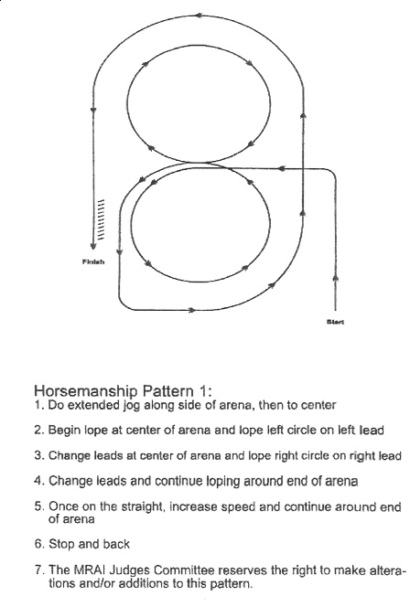

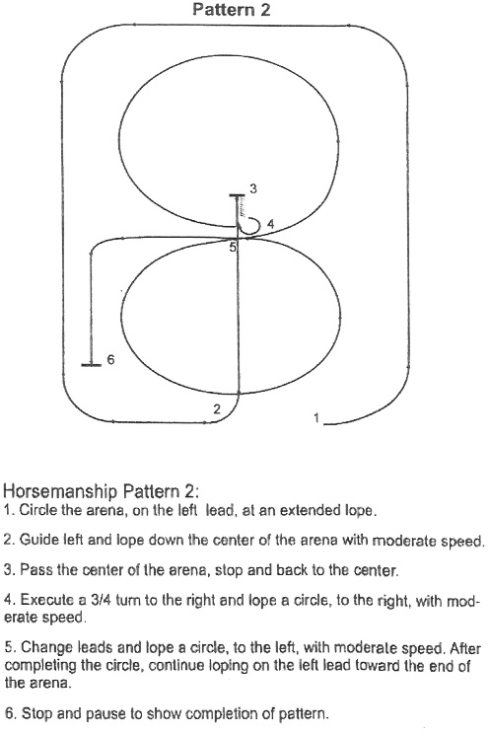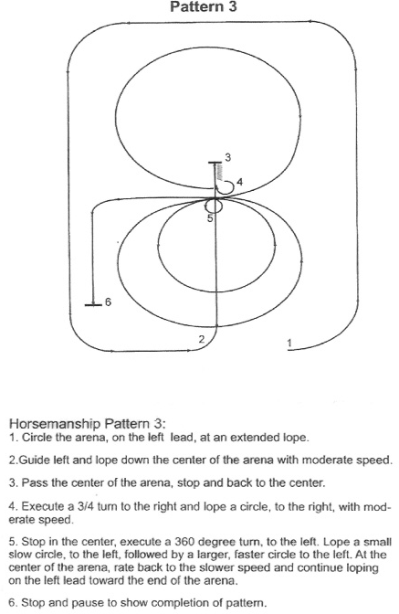

Formal Complaint/Grievance Process:
Any complaint that is filed in regard to Miss Rodeo Florida Pageant operations or issues must adhere to the following:

1. All complaints must be submitted in writing.
2. Complaints must include the name, address and daytime phone number of the person filing the complaint.
3. The complaint should include as much detail about the subject as possible in order for appropriate action to be taken.
4. Complaints may be submitted to any of the following:

Jessica Kelly, Pageant Director, Missrodeoflpageant@gmail.com
Laura Lynn Kessler, National Director, krazykrooner@aol.com

5. Complaints must be signed and dated.
6. If a response to the complaint is desired, the letter must indicate so.
7. Any complaints that do not follow the above process will be classified as invalid.

MRF Association follow-up procedure:
- All complaints will be reviewed by the Executive Board. An Executive Board member will be assigned to research and gather information about the situation. All parties involved will be notified about the complaint and given the opportunity to provide a response.
2. A time frame will be established for the issue to be addressed.
3. Findings will be reported back to the Executive Board.
4. The Executive Board will vote and determine necessary action to be taken.
5. An Executive Board representative will report back to all parties involved.

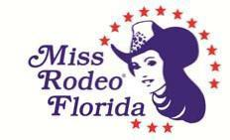

MISS RODEO FLORIDA ASSOCIATION, INC.
MISSION STATEMENT

It is the mission of the Miss Rodeo Florida Association, Inc., to produce a professional state pageant for the purpose of selecting a ―Miss Rodeo Florida and ―Miss Teen Rodeo Florida. who will serve the great state of Florida as official ambassadors and spokeswomen for the professional sport of rodeo and our western traditions. By recognizing the importance of promoting a positive image and awareness of rodeo while preserving our western heritage, our goal is to support, guide, educate, and offer direction to these young ladies so that they may be better prepared to serve with the highest level of integrity and professionalism, as role models, to educate the public as they travel throughout the state and across the nation. It is also our purpose to assist, support and groom the reigning Miss Rodeo Florida for the ultimate challenge of competing in the Miss Rodeo America Pageant as the official representative from the State of Florida.

