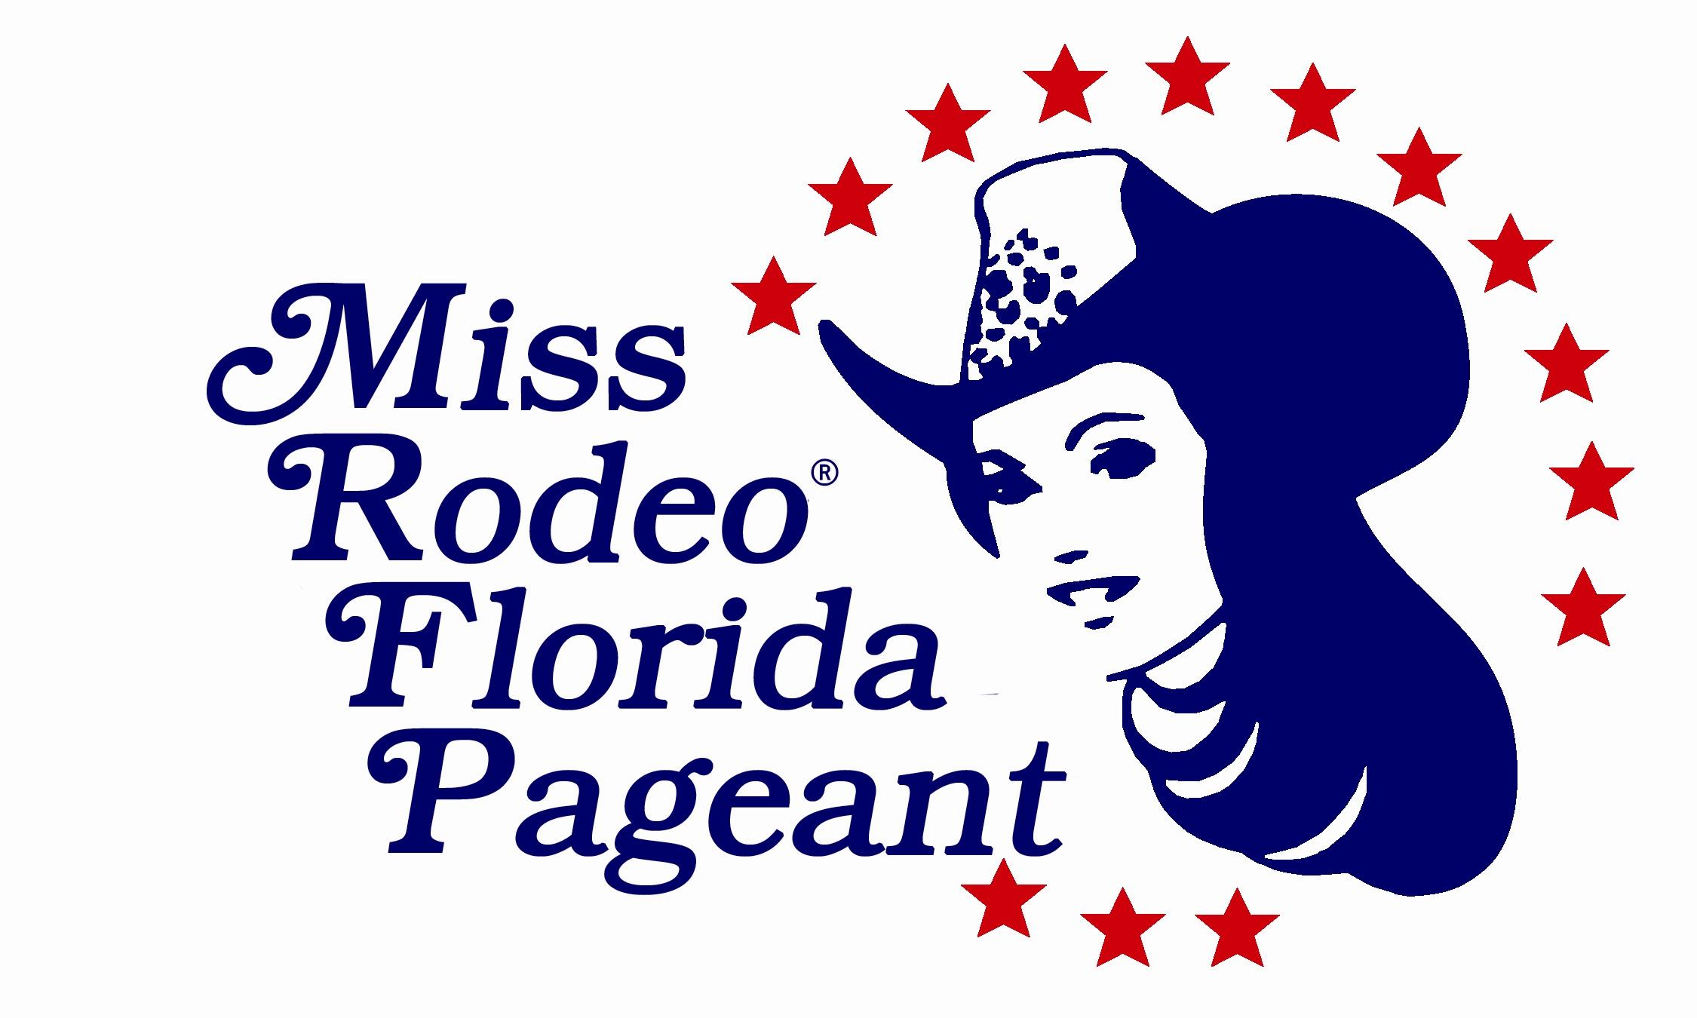
MISS RODEO FLORIDA _______________________________
MISS TEEN RODEO FLORIDA _______________________________
MISS RODEO FLORIDA PRINCESS _______________________________
MISS RODEO FLORIDA SWEETHEART _______________________________

ADVERTISING AGREEMENT

The Miss Rodeo Florida 2022 Pageant will be held September 10 – 12, 2021 in Osceola County Florida. Each contestant is required to sell a minimum of $150.00 in ads for the program book. 10% of any additional ad sales over the $150.00 will be given back to the contestant to assist her in her quest for the title.

The pageant is open to young ladies between the ages of 7 and 27 years of age that are residents of Florida. The newly crowned Miss Rodeo Florida will compete for the coveted title of Miss Rodeo America in December.

Thank you for your support for these young ladies and this program!
____________________________________________________________________________________

Program Trim Size: 8 ¼” X 11”/ Image Area: 7 ½” X 9 ¾”

1. AD SIZE: PLEASE CIRCLE

1/8 Page...........................................$ 35.00
3 -5/8” W X 2-1/4” H

1/4 Page...........................................$ 50.00
3 -5/8” W X 4-3/4” H

1/2 Page...........................................$ 75.00
7-1/2” W X 4-3/4” H

Full Page........................................ $100.00

Photo in Ad……………………… $ 10.00 Per Photo
Photo must be provided. The program is in all color. The photo will be returned upon request.
Please put contestants name on back of photo.

ADVERTISER NAME:___________________________________________________
ADVERTISER SIGNATURE:______________________________________________
ADVERTISER ADDRESS:________________________________________________
_______________________________________________________________________
ADVERTISER PHONE NUMBER:__________________________________________

MAKE CHECK PAYABLE TO: MISS RODEO FLORIDA ASSOC., INC.
WRITE AD COPY ON ATTACHED SHEET
Miss Rodeo Florida Association, Inc*4876 Oriole Drive
St. Cloud, Florida 34772
Questions email: lkess@osceola.org

I

FULL PAGE
( 7 1/2”X 9 3/4” )
BLACK INK
$100.00

1/2 PAGE
( 7 1/2” X 4 3/4” )
BLACK INK
$75.00

1/4 PAGE
( 3 5/8” X 4 3/4” )
BLACK INK
$50.00

THANK YOU FOR YOUR SUPPORT FOR THE MISS RODEO FLORIDA ASSOCIATION PROGRAM!

1/8 PAGE
( 3 5/8” X 2 1/4” )
BLACK INK
$35.00

